Issues faced

**#1**

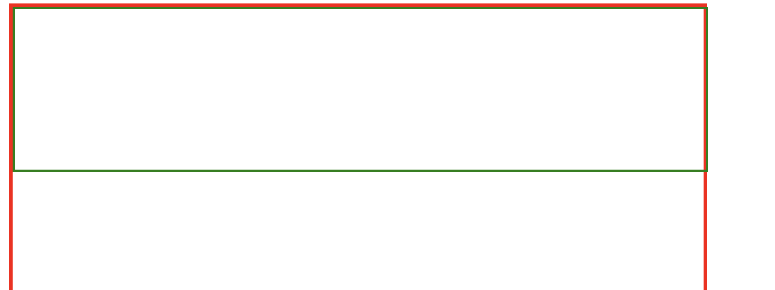

Here you can see the green box is coming outside red box, to solve this issue, we use

html {

box-sizing: border-box;

}

*, *:before, *:after {

box-sizing: inherit;

}

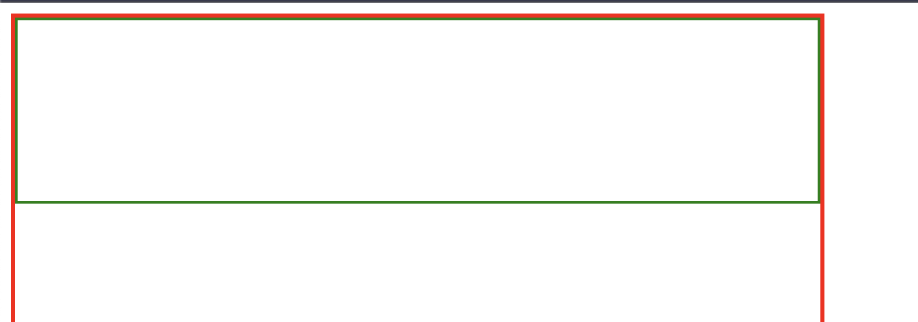

Now, if we use border-box then the issue is resolved.

First we build the layout like the divs and give id in html and then border in css and then we put in the text and then solve the issues. So, we get the below one before putting text.

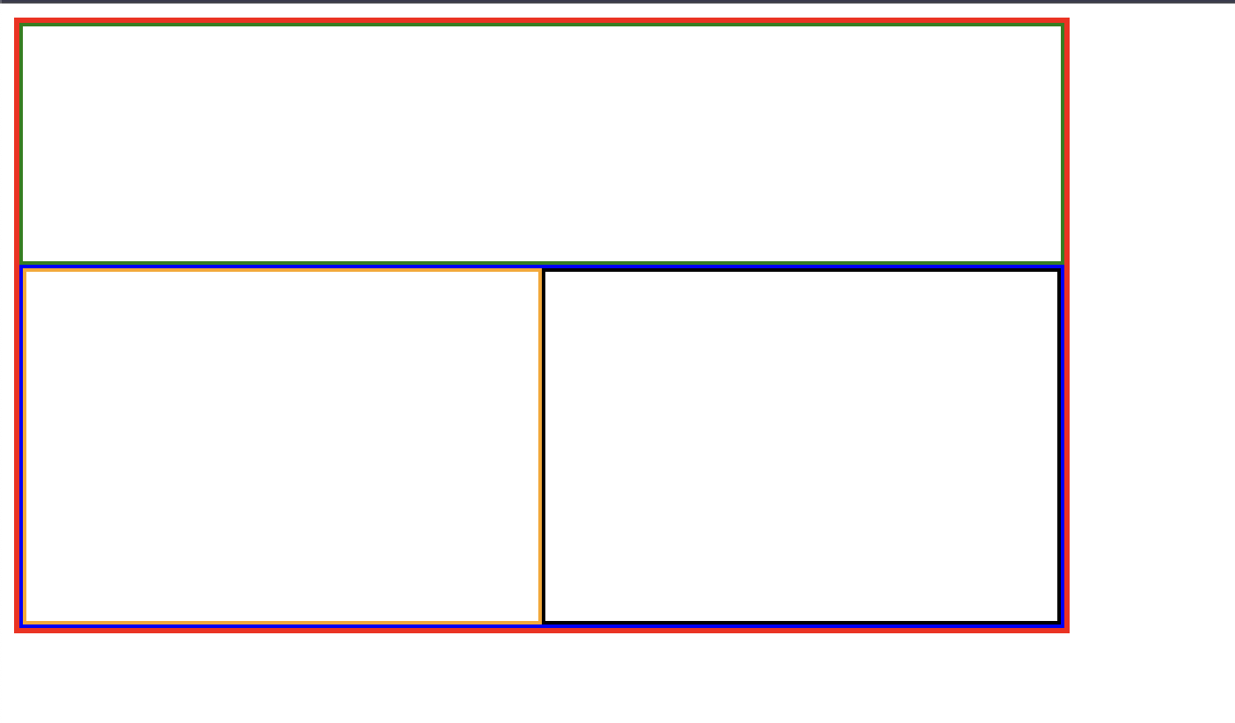

**#2**

* Div is a block element so in the bottom section we have two divs bottom-left and bottom-right so, if we assign the styles let say border to these two they come one after the other instead of side by side because div is a block element
* When it comes to inline, it won’t respect the width and height but we want our boxes to respect that
* So, we make those two divs as inline-block
* #bottom-left-section {
* display: inline-block;
* width:50%;
* height:100%;
* border: 2px solid orange;
* }
* #bottom-right-section {
* display: inline-block;
* width:50%;
* height:100%;
* border: 2px solid black;
* }

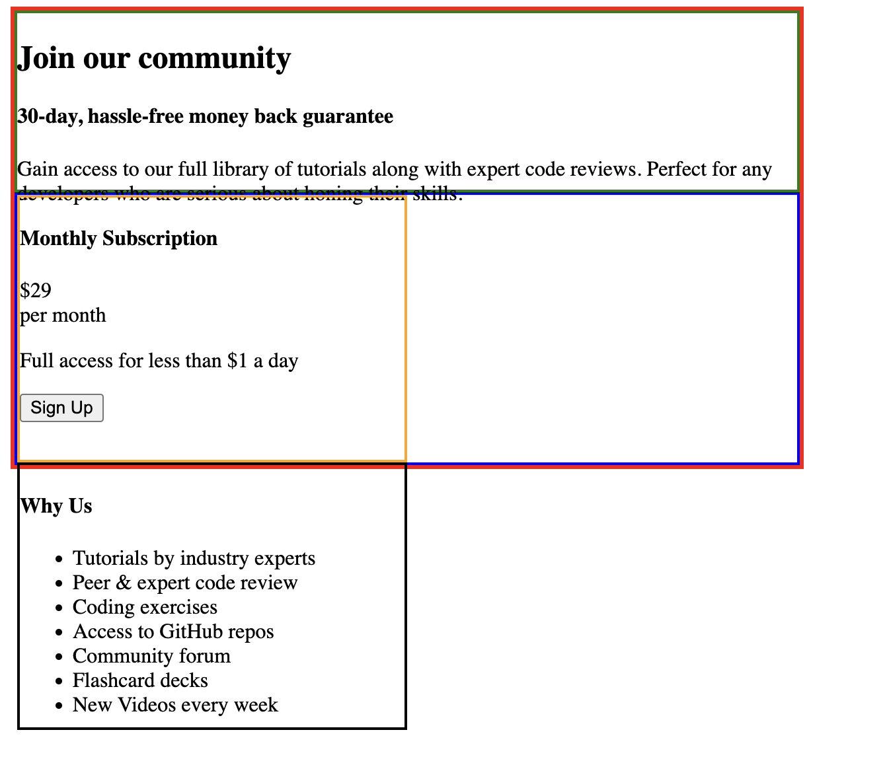

But still they are not side by side in the bottom section

Reason is that in the html code

<div id="bottom-section">

<div id="bottom-left-section">

<h4>Monthly Subscription</h4>

<div>

<div>$29</div>

<div>per month</div>

</div>

<p>Full access for less than $1 a day</p>

<button>Sign Up</button>

</div>

<div id="bottom-right-section">

We can see the space between bottom-left-section ending div and bottom-right-section starting div. And css considers this as white space and the inline-block element does respect this white space so the issue. To resolve it, if we just make the end and start side by side as shown below. Then the issue was resolved.

<div id=”bottom-left-section”>

</div><div id=”bottom-right-section”></div>

**#3**

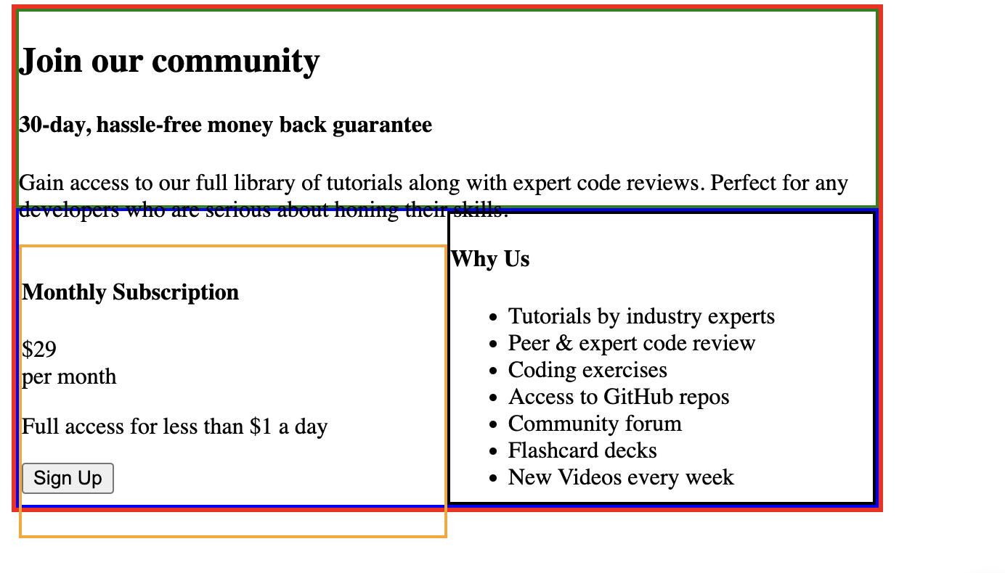

Here, after putting the text in the boxes this happens due to the default margin for h2 and h4 and p elements. But how do you know this?

If you click on inspect, you can see the padding and margin around the text.

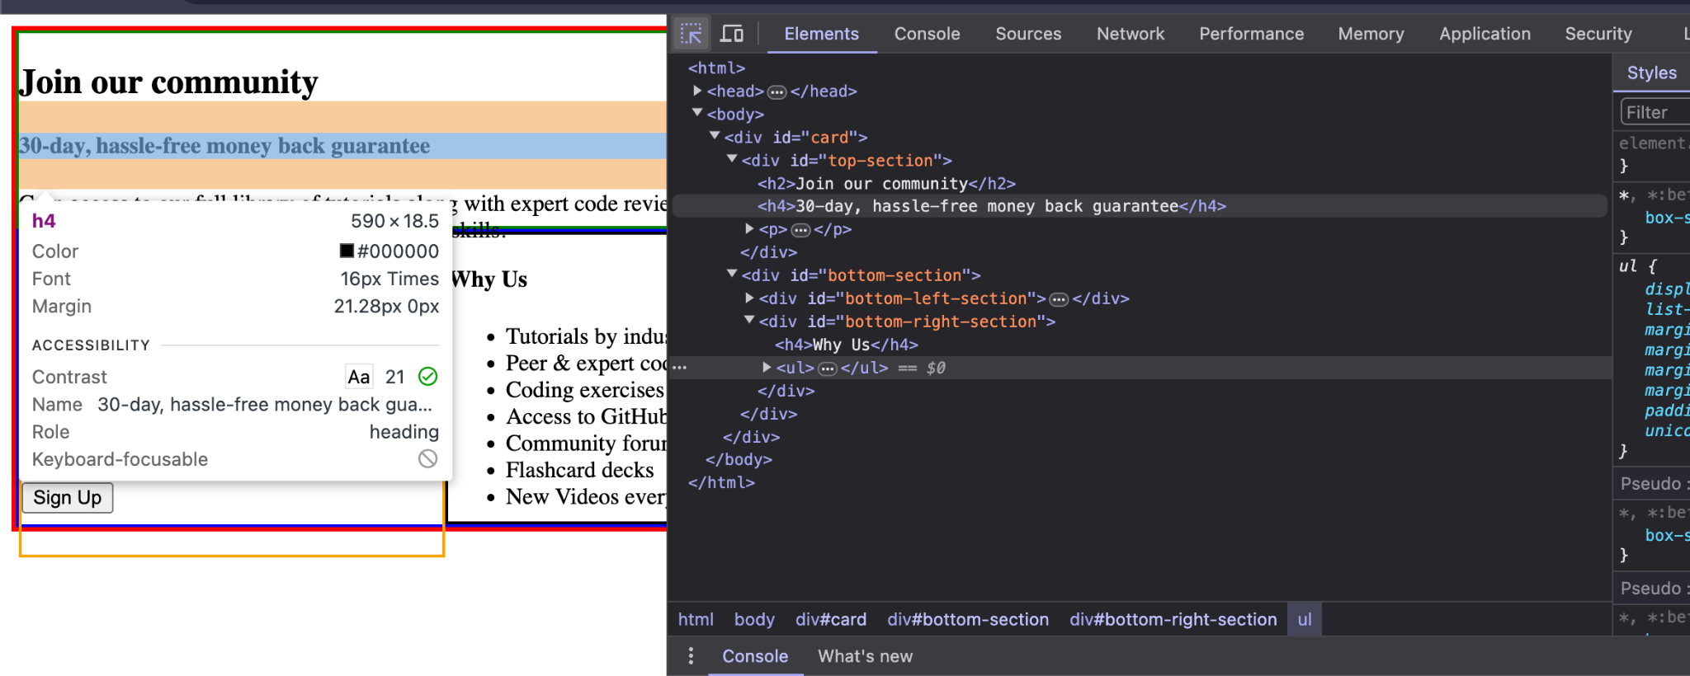

To resolve this issue -

h2, h4, p {

margin: 0;

}

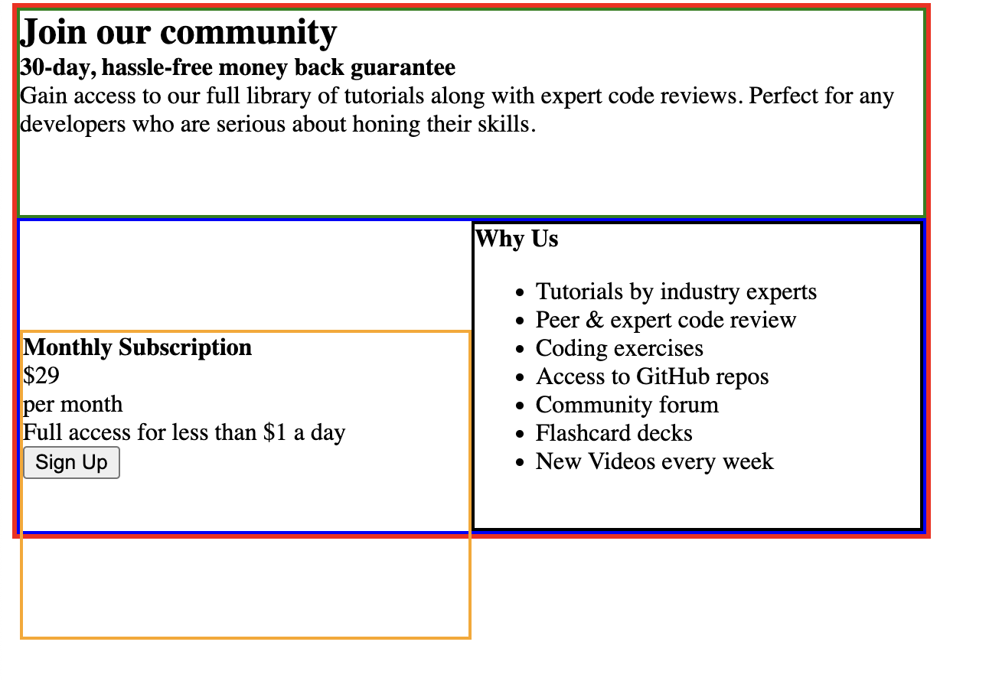

Here, the text is inside the boxes.so, the margin issue is resolved. But a new issue arises with the orange box.

**#4**

Issue with orange box.

This is because when we change the display the properties also change. So for inline-block elements we use vertical-align(which is not applicable to block elements) we want the text to be at the top.

#bottom-left-section {

display: inline-block;

width:50%;

height:100%;

border: 2px solid orange;

vertical-align: top;

}

#bottom-right-section {

display: inline-block;

width:50%;

height:100%;

border: 2px solid black;

vertical-align: top;

}

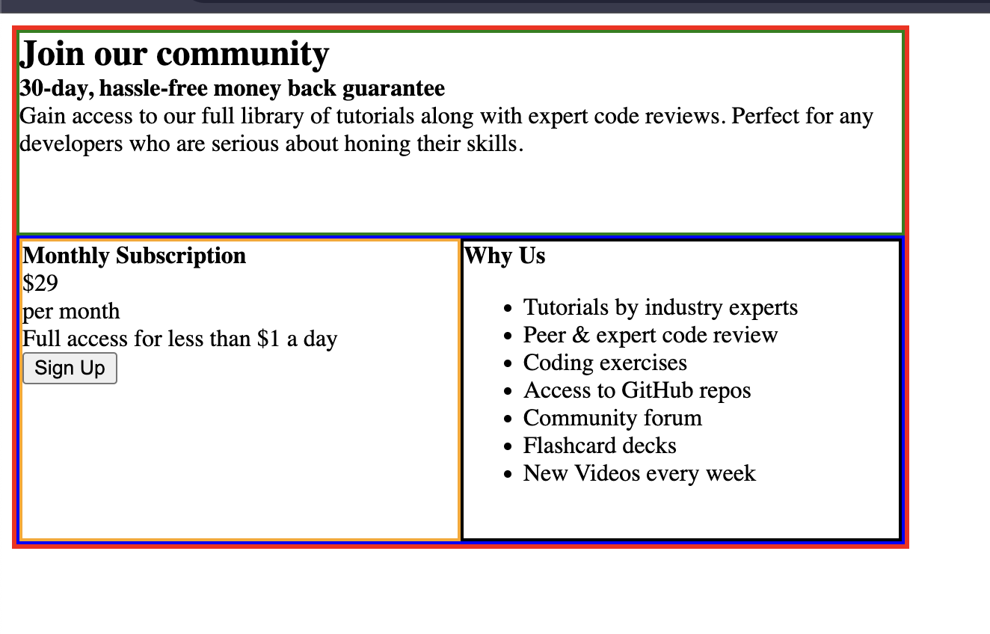

Now, the output is with the layout we want.



Now, to move this right side a bit

We use

body {

padding: 20px;

}

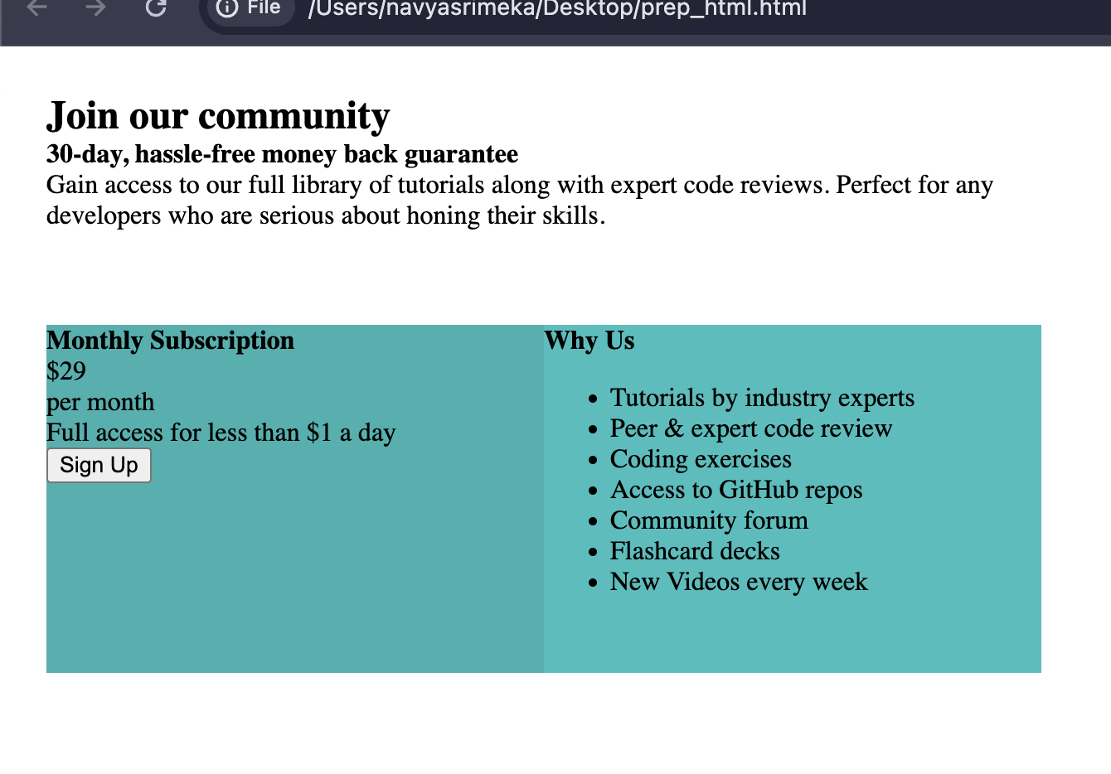

Now, to slightly make our card float i.e a defined edge like box-shadow to get this by googling and changing parameters <https://box-shadow.dev/>

#card {

width: 600px;

height: 350px;

box-shadow: 2px 3px 7px 0px rgba(0,0,0,0.35);

}

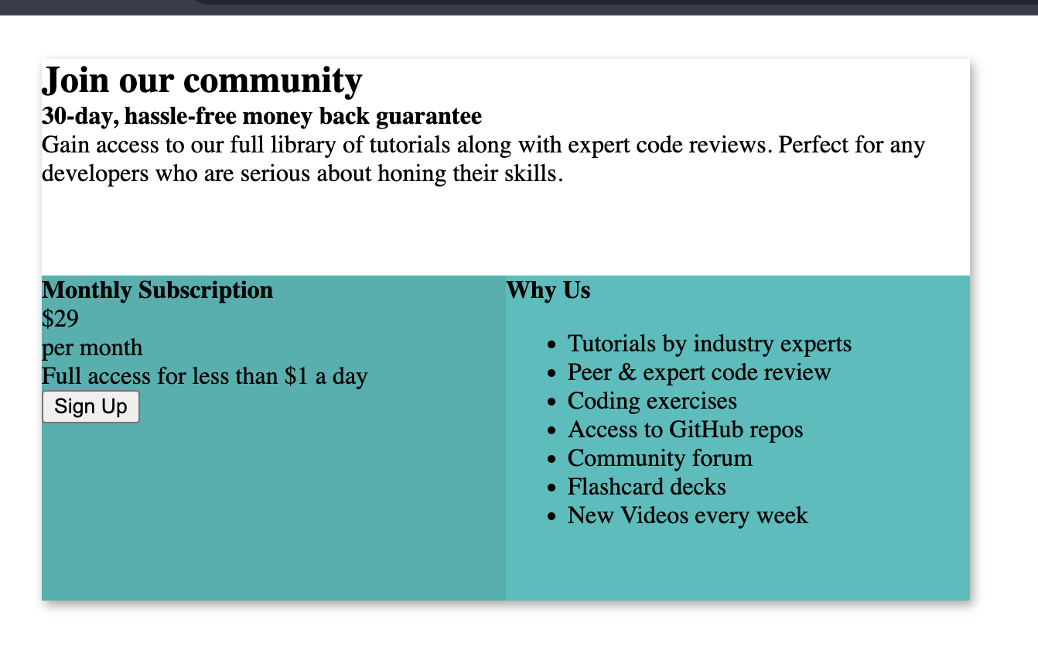

**#5**

To make the border rounded-

We use border-radius

#card {

width: 600px;

height: 350px;

box-shadow: 2px 3px 7px 0px rgba(0,0,0,0.35);

border-radius: 5px;

}

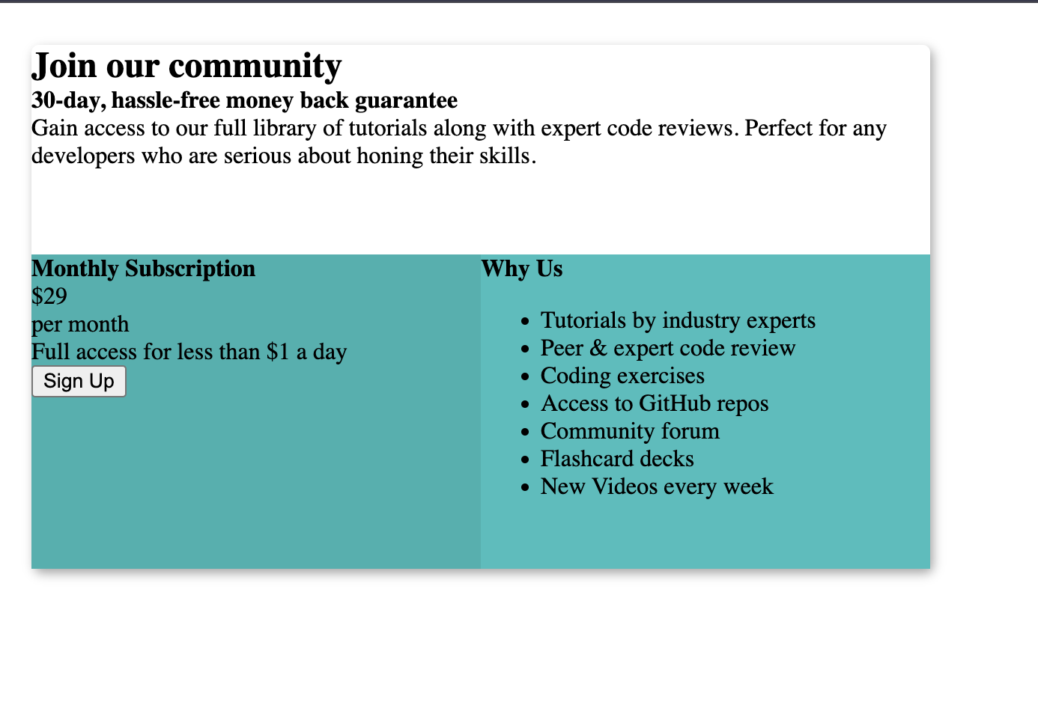

But here, we have rounded only for top corners but both bottom left and right corners are sharp but why?

Because we have two separate boxes in the bottom which are squares so, when we apply the radius this inside squares(i.e children containers of the main container) are overflowing outside hence we use below code.

#card {

width: 600px;

height: 350px;

box-shadow: 2px 3px 7px 0px rgba(0,0,0,0.35);

border-radius: 5px;

overflow: hidden;

}

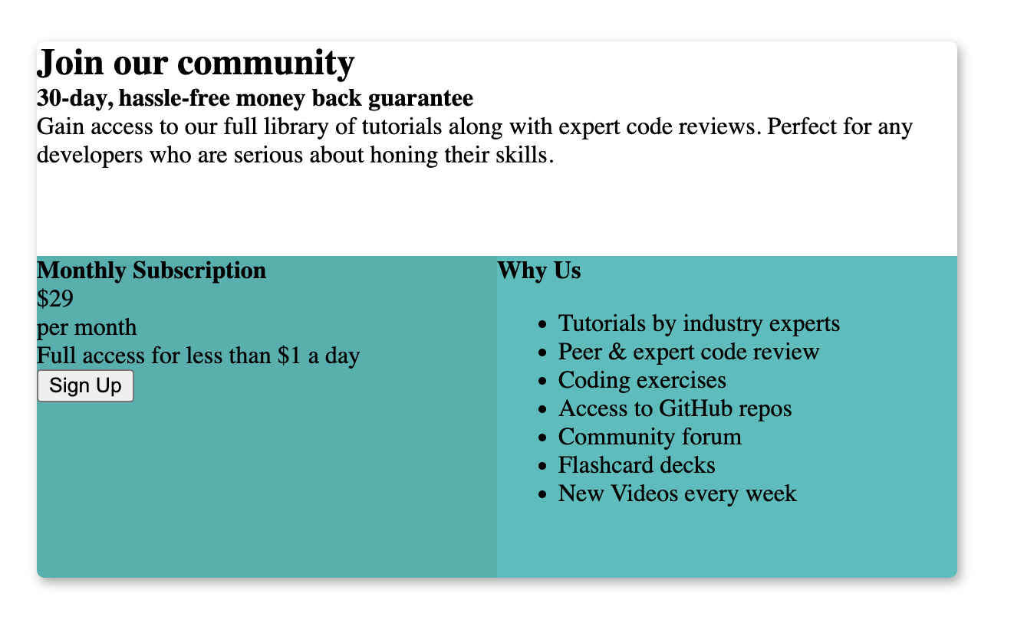

**#6**

To get all the space we around as we see in the design

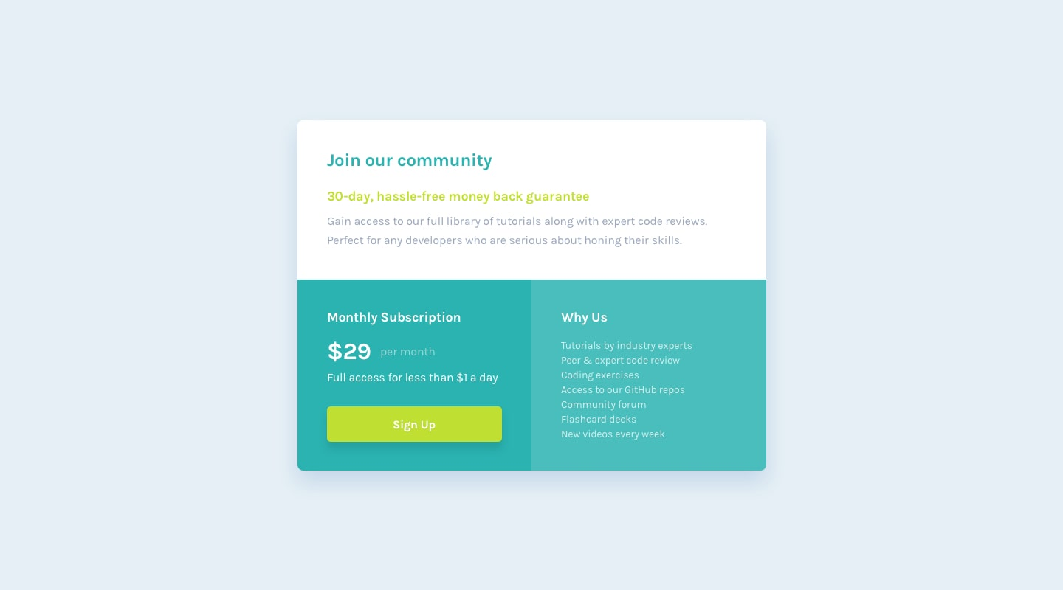

We need to add padding to the card but that gives output like this

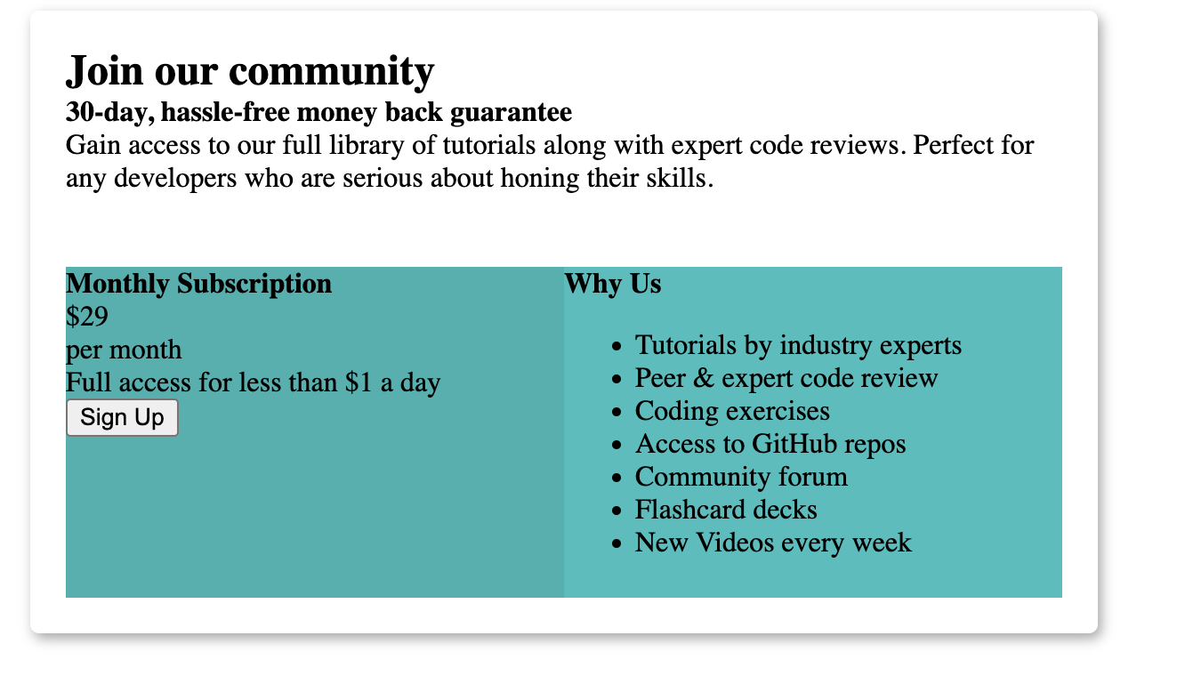

But this is not what we want, hence we remove this padding to the whole container and add it to the individual elements.

So, we add padding to top section and bottom-left and bottom-right sections

We don’t add to bottom section because it causes the same issue as shown earlier

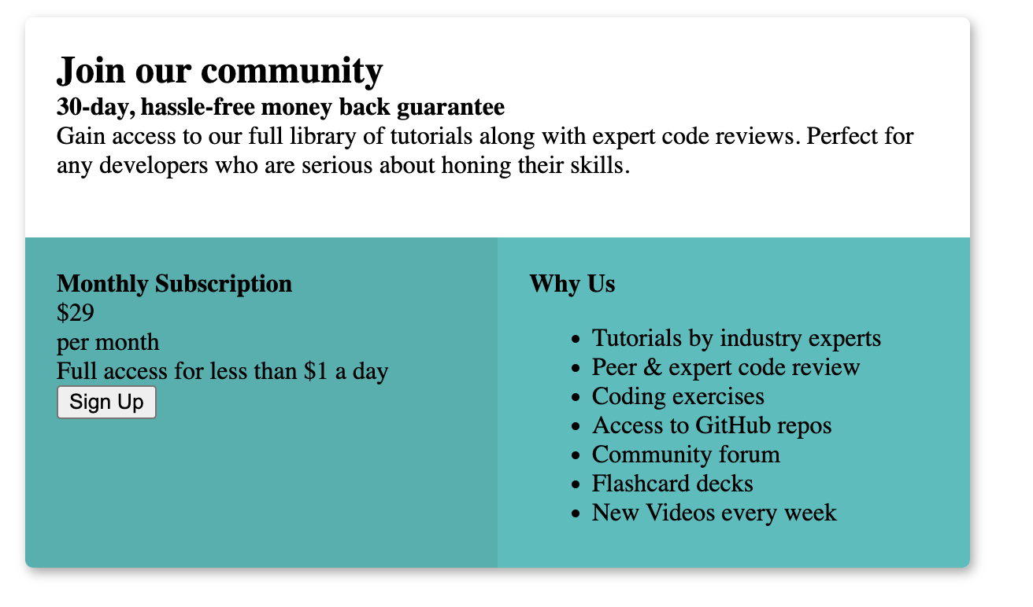

To add more spacing around the button



We add padding



And we need to make the button the same as the box size in terms of width. When we look at the design we can see that.

To create space between these two lines, we can set the margin



Here, per month is not in line with price to that we make those both as inline-block elements



Now, here per month is a little bit below $29, hence we use relative position and move it top.

#price-frequency {

position: relative;

top: -3px;

}



To remove the bullet points -



If we inspect the element we can see the padding and margins



Yellow is margin it is fine

Green is padding

So, we remove it then everything moves to the left and remove bullet style.

ul {

padding: 0px;

list-style: none;

}



Button-



When we place a cursor on it, we make it

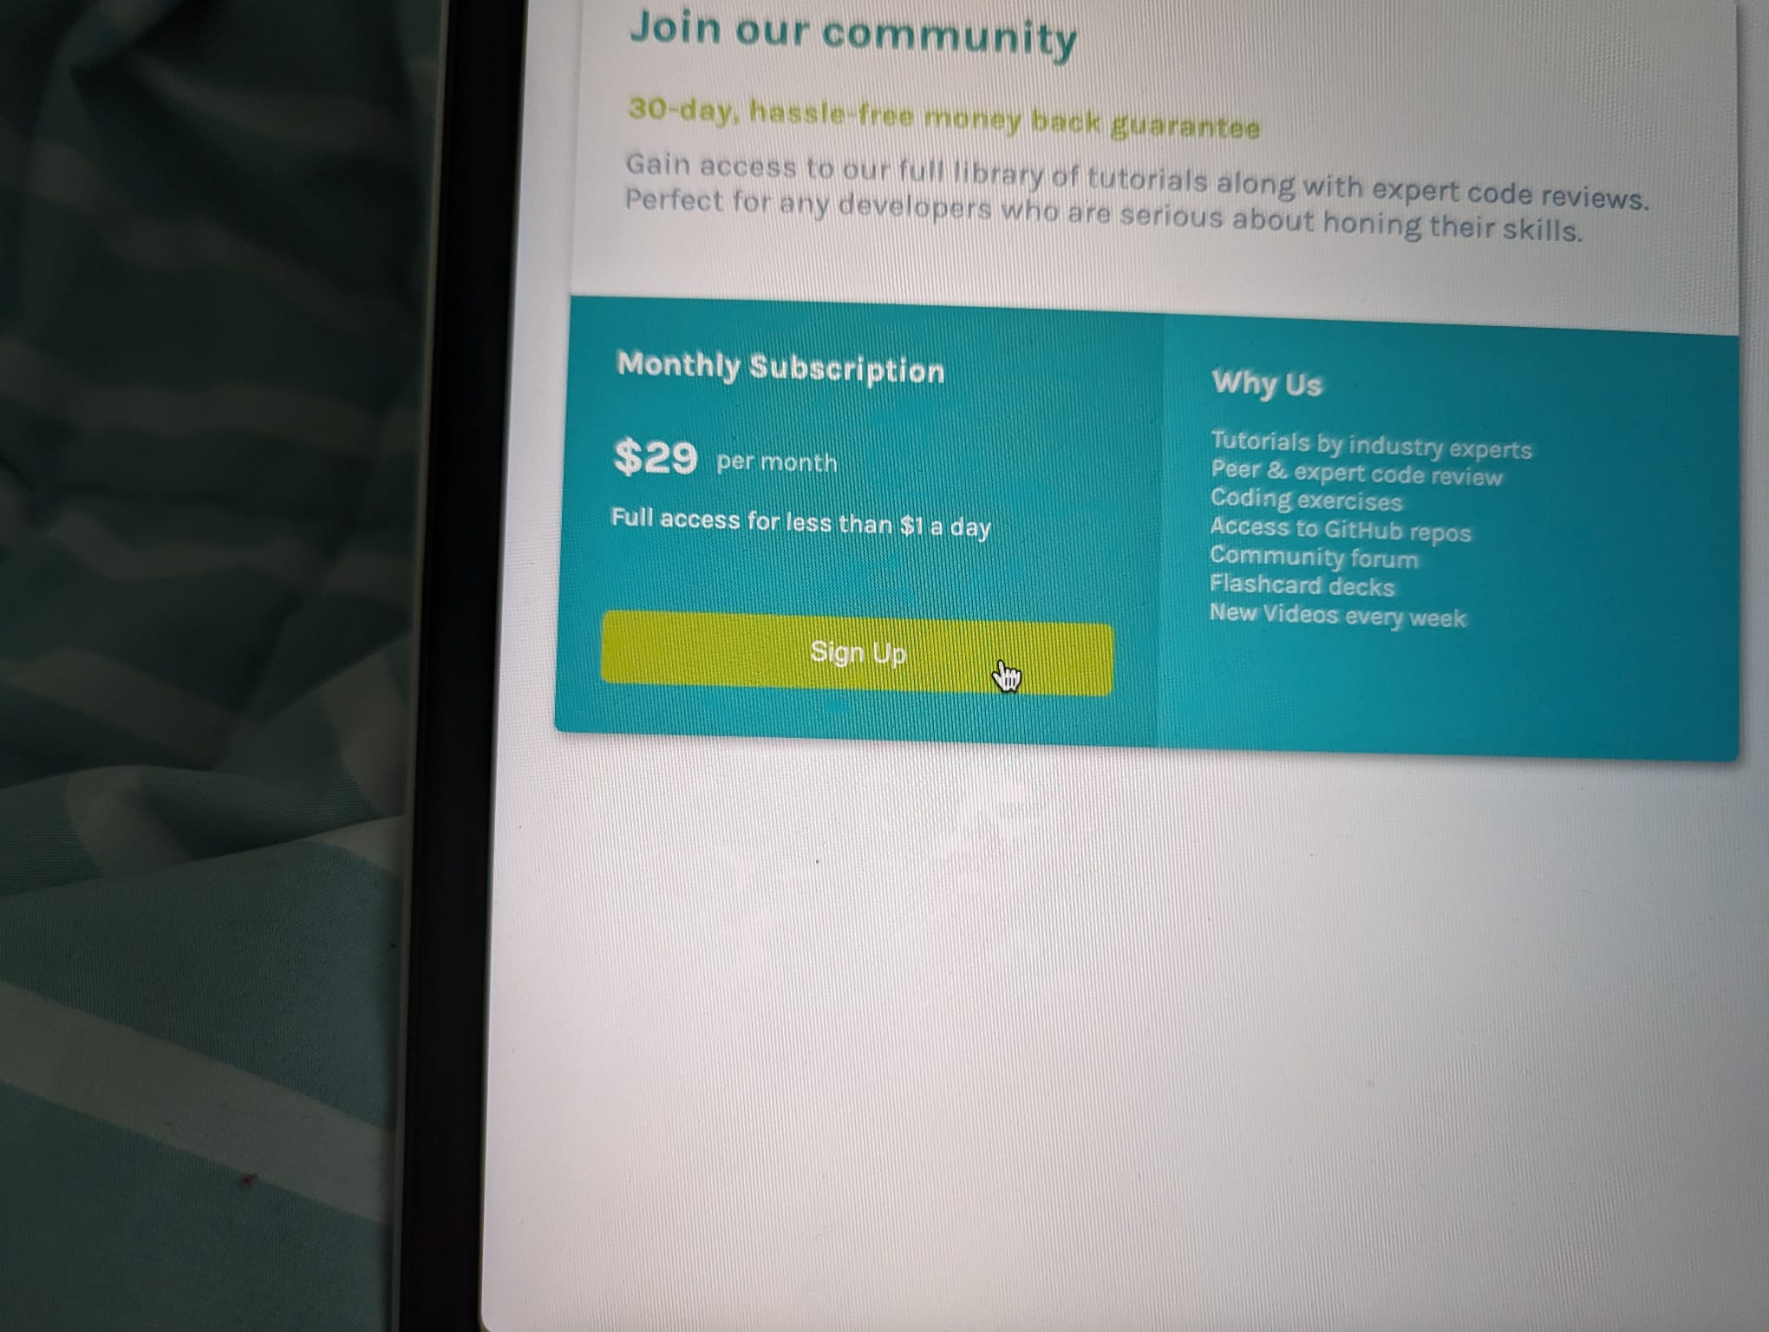

button:hover {

cursor: pointer;

background-color: #A9C42D;

transform: scale(1.02);

}